**Hands-On Exercises: Authentication and Authorization in ASP.NET Core Web API Microservices**

This document contains 4 hands-on exercises focusing on Authentication and Authorization in ASP.NET Core Web API microservices, with an emphasis on implementing JWT (JSON Web Tokens) authentication. Each exercise includes a scenario, step-by-step instructions, and complete solution code.

**Question 1: Implement JWT Authentication in ASP.NET Core Web API**

**Scenario:**

**You are building a microservice that requires secure login. You need to implement JWT based authentication.**

Steps:

1. Create a new ASP.NET Core Web API project.

2. Add a `User` model and a login endpoint.

3. Generate a JWT token upon successful login.

4. Secure an endpoint using `[Authorize]`.

Solution Code:

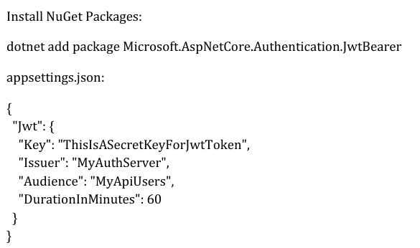

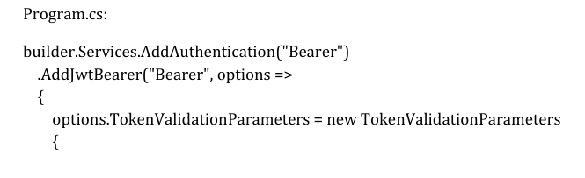

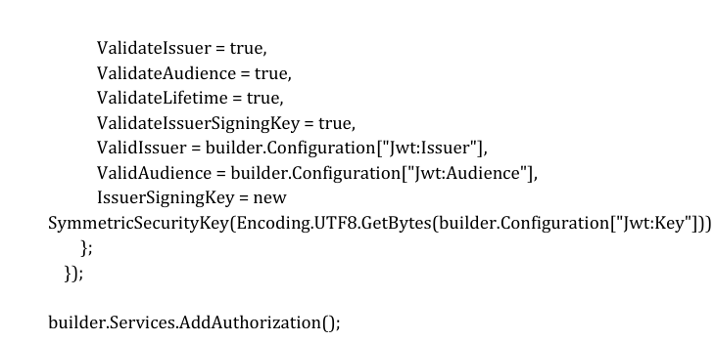

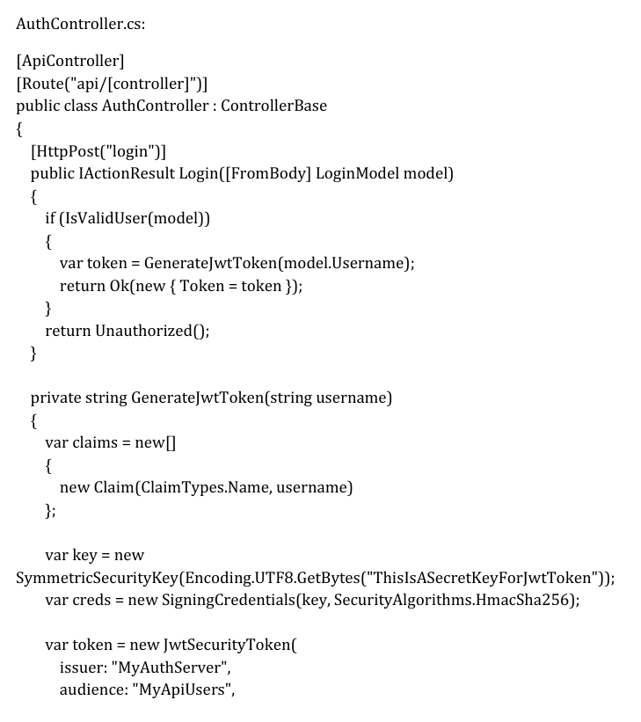

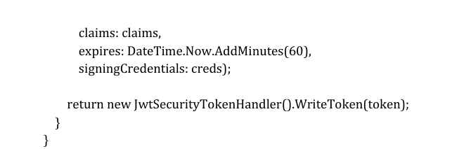

OUTPUT:

